Alexander Baldree, Jordan Dardar, Max Jankowski, Aftabur Rahman
Bellevue University
CSD460 Module 1 User stories

User Stories:

Users:
- Dan Novak
  - 58 Year old Contractor that’s almost retired
  - Has 34 ft Cruiser
  - 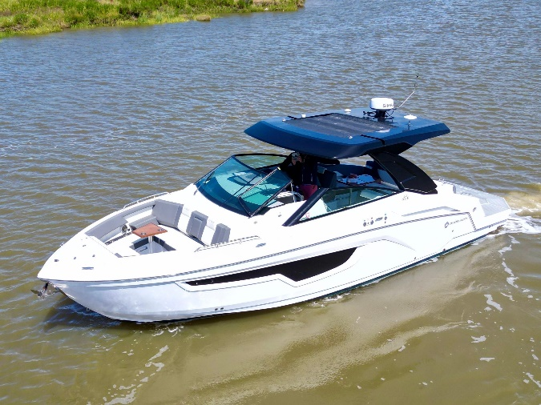

- John Larson
  - 45 year old Fishery Consultant
  - 39 ft workboat
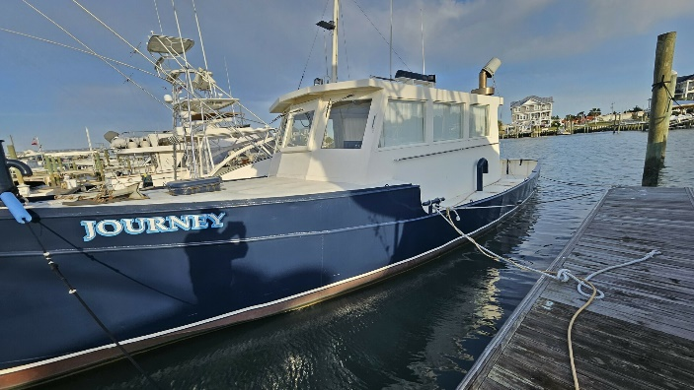

- Henry Morrison
  - 62 year old fishing boat captain (retired)
  - 48 ft Trawler
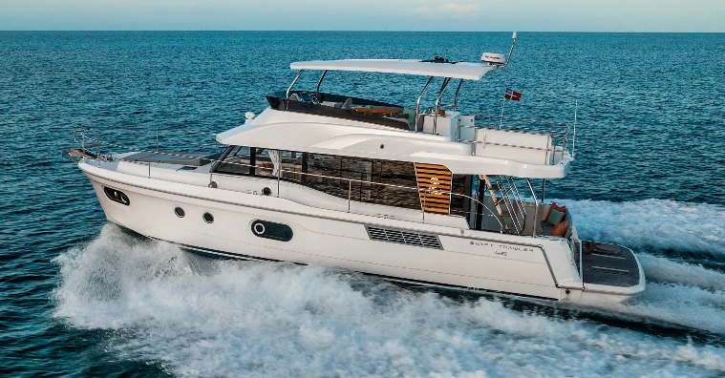

- Priya Sharma
  - 39 year old Software project manager
  - 26 ft sailboat
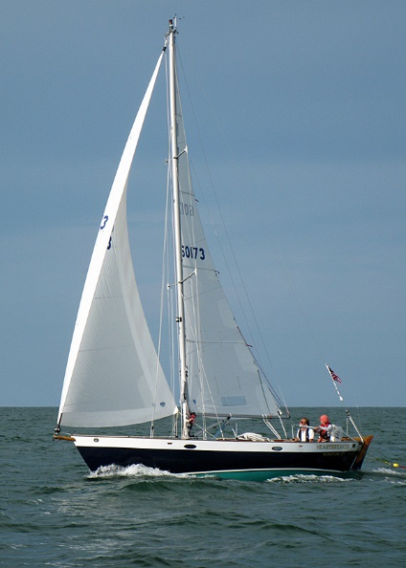

- Emily Tran
  - 37 year old ER nurse
  - 36 ft Powerboat (She does well)
